***Ahsanullah University of Science & Technology***

Department of Computer Science & Engineering



(Library Management System)

Information System Design

&

Software Engineering Lab

**CSE-3224**

Submitted By:

MD. Musad Al Rubayet 15-01-04-069

Md. Jahid Shah Shiamun 15-01-04-071

Fairuz Shadmani Shishir 15-01-04-082

**List of the Contents:**

|  |  |
| --- | --- |
| 1. Executive Summary Of Project .....................................  2.Project Goals and Platforms ...........................................  3.Requirements and Feasibility Analysis ......................  4. Data Flow Diagram of the project ...............................  5. USE CASE Diagram of the project ................................  6. Entity Relationship Diagram of the Project ............  7. Testing result of project ..................................................  8. Opportunities of Developments ..................................  9. Benchmarking .....................................................................  10. Reference ........................................................................... | 3  3  4  5-9  9-12  13-16  17-18  18  19  19 |

# Executive summary of the project

We have built a Desktop application for Library management system. We have created a database for maintaining their records of students, books, and other services.There will be an admin who can insert, delete and update the information. So these are the features we have done in this system:

* Manage the complete management of the entire library through the software’s easy interface.
* It removes manual process of issuing books by easy and simplified way of issuing book saving time and effort.
* The librarian can issue, return and reserve book for a particular student through the software’s interface.
* The software automatically shows fine levied by automatically counting days from the date if issue in case of late return of the book.
* Add, update, search and view library items.
* Generate customized report for library items, library inventory and library fine collection.

# project goals and platforms

Project Goals:

Our goal is to create a simple application which helps the admin of the library to manage their students and books more efficiently. For our project AUST Library will serve as our source of all data and design.

As students, we believe taking on a project like this can teach us a lot about the professional field and the aspects of building feasible, durable software. At the very least, our goal for this project is to learn about software engineering and working with real life clients.

Platforms:

1. OS: Windows
2. Platform: C#
3. Server: ASP.Net
4. DBMS: MySQL
5. Applications : Visual Studio

# Requirements and Feasibility analYsis

Requirements:

* Provide user friendly interface that is easy to use for the user mean the admin.
* Provide a system that is fast & secure.
* Provide the administrator with access to all kinds of information of students and books
* Provide protection for administrative information.

Project Feasibilities:

1. Technical Feasibility:

This is platform independent so mac, windows users can use this software. We will use C#, .Net for our front-end and back-end we have used mysql .

1. Economic Feasibility:

Most of the resources used in this project are free of cost so we develop this project at a very low cost. Other costs that are included in this project are:

* Cost of programmer’s time
* Cost of internet
* Transportation cost for developers

1. Operational Feasibility:

* In our project manual work will be reduced, time will be saved.
* Human resources involving in the project will be available to operate the system. So this project will be operationally feasible.
* This project will have a very user friendly interface to communicate with the user.
* The system is robust, so there is very few possibility of any kind of crashing and damage.

# Data Flow diagram of the project

Data Flow Diagram deals with one of the major techniques for recording the requirements of a user for a new computer application. An initial diagram is constructed to show the processes which are being implemented in an existing system. The diagram helps to show how information is used to produce the functions that are required by the current system. It also shows what information is provided to the system and what information is provided form the system. Other benefits include the documentation of who is using the system and what data will be stored. By careful construction of the DFDs (data flow diagrams) the boundaries of the system to be built may be clearly identified.

ACTIVITIES OF THE PROJECT:

Our project, Library Management mainly consists of the following activities:

* Admin can approve student’s book request
* Admin can update, delete or add information
* Admin can appoint employees
* Admin can pay the employees and suppliers
* Student can borrow and return books
* Student will be notified through email for return books

**Entities:**

1.Admin

2.Students

3.Employee

4.Supplier

**Database Names:**

1.Admin info DB

2.Student info DB

3.Employee DB

4.Book DB

5.Purchase DB

6.Payment DB

7.Issue books DB

**Context Level Diagram**

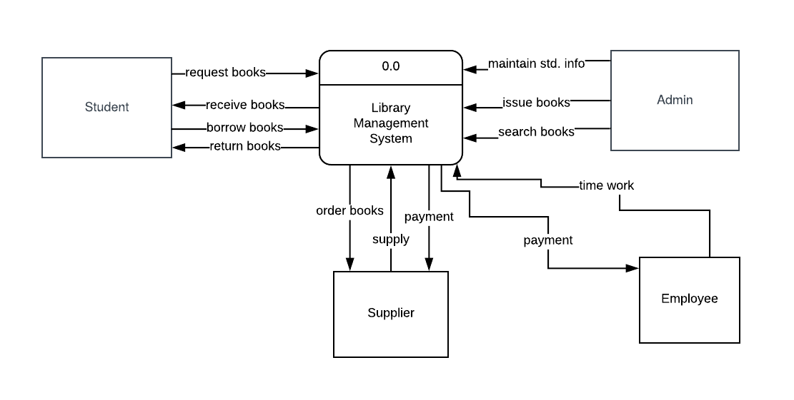

**LEVEL 0 DIAGRAM**

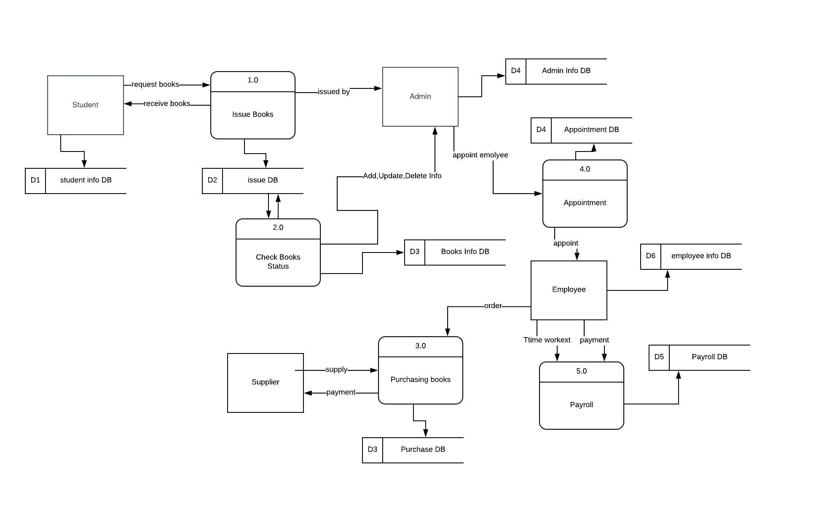

**LEVEL 1 DIAGRAM (Appointment Process)**

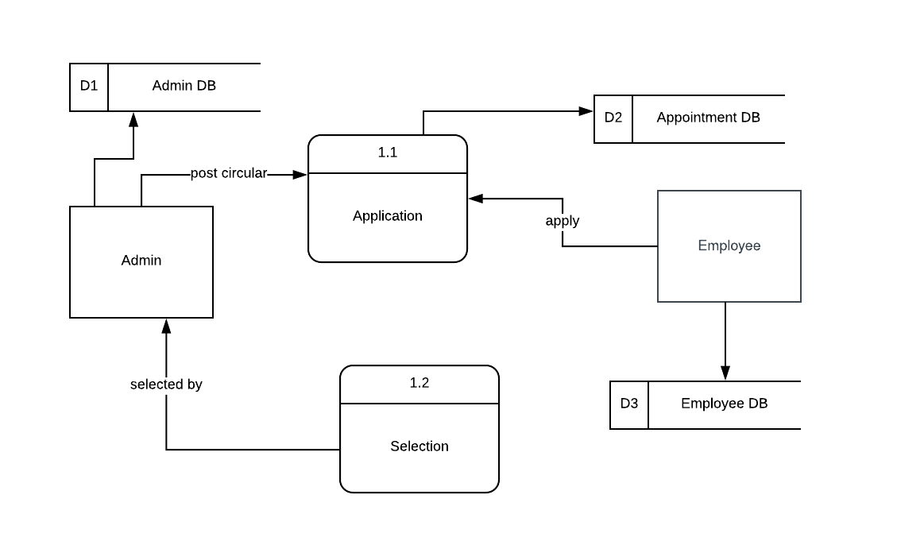

**Level 1 Diagram (Issue Books Process)**

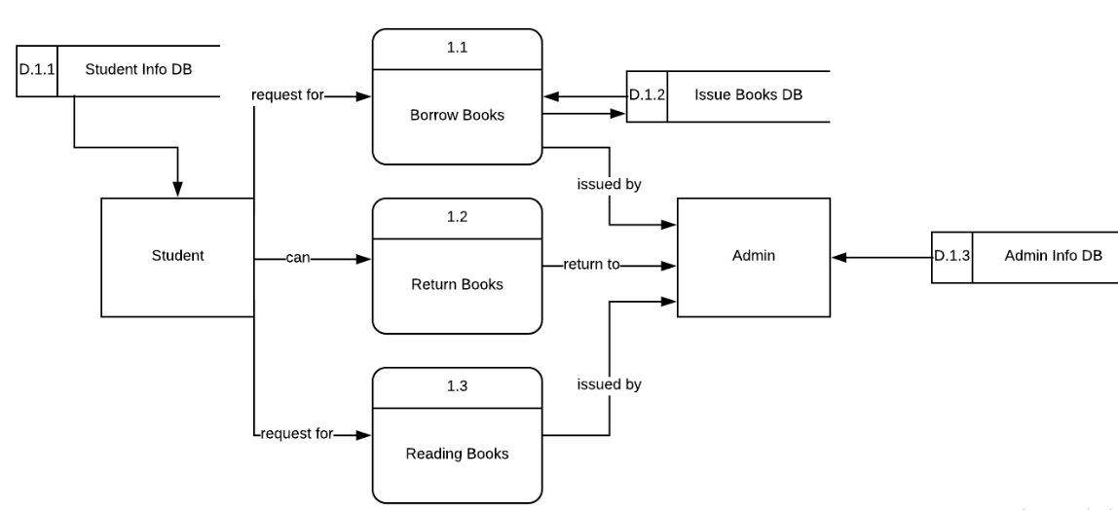

**Level 1 Diagram (Purchase Process)**

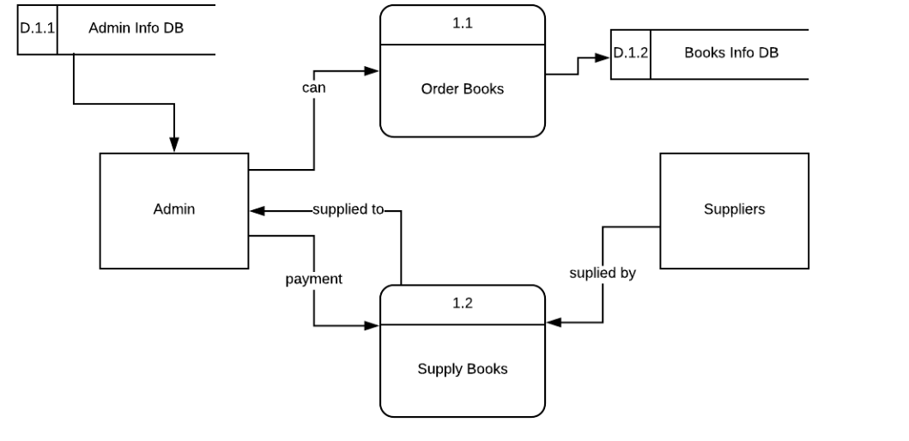

**Level 1 Diagram (Book Status Process)**

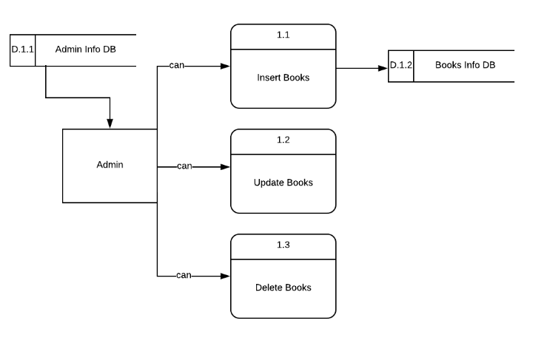

# Use case Diagram of the project

The use case model describes the proposed functionality of the new system. A use case is a single unit of meaningful work; for example: login to system, register with the system and create order are all use cases. A use case may include another use cases functionality or extend another use case with its own behavior.

Use cases are typically related to ‘actors’. An actor is a human or machine entity that interacts with the system to perform meaningful work.

**Actor:**

An actor is a user of the system. This includes both human users and other machine or computers. An actor uses use case to perform some piece of work which is of value to the business. The set of use cases an actor has access to define their overall role in the system and the scope of their action.

The Actorsof a system can be defined as anyone or anything that interacts with the system to achieve a particular goal. Keeping this in mind, our system has 2 primary actors:

* **Admin:** Library person mean the librarian who maintain the whole system.
* **Student:** General students who can borrow books, return books and read books from our library.

**Use Case:**

We have already discussed that an actoris a person or a thing that has a particular goal in using a system. Now, a use case can simply be defined as the goal the actor aims to achieve. That is, use cases are the actions performed on a system initiated by an actor. Now, let’s look at the possible use cases in our project:

**USE CASE MODEL**

Use case (Combined):

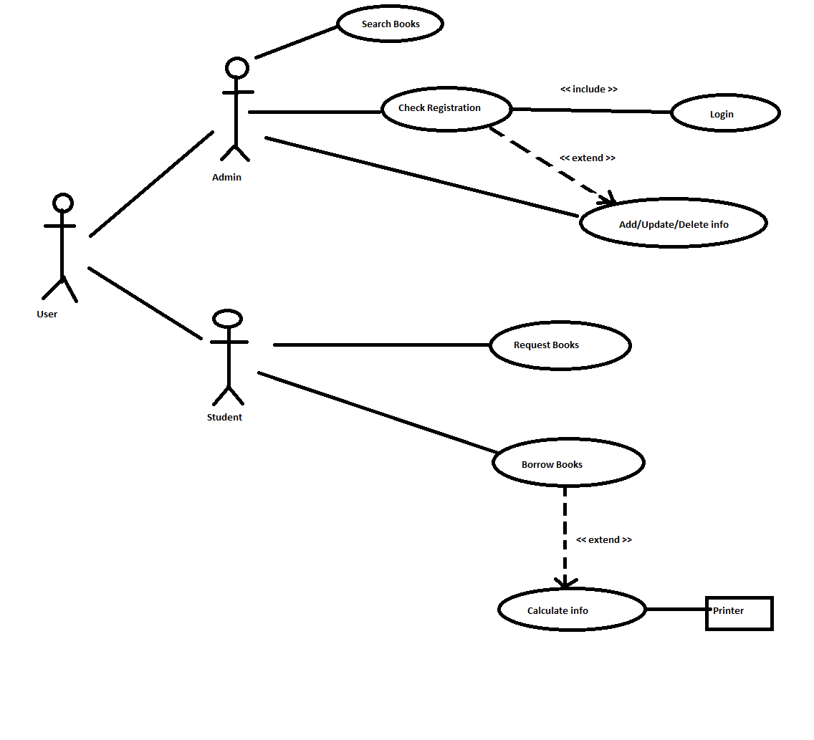

Use case for student:

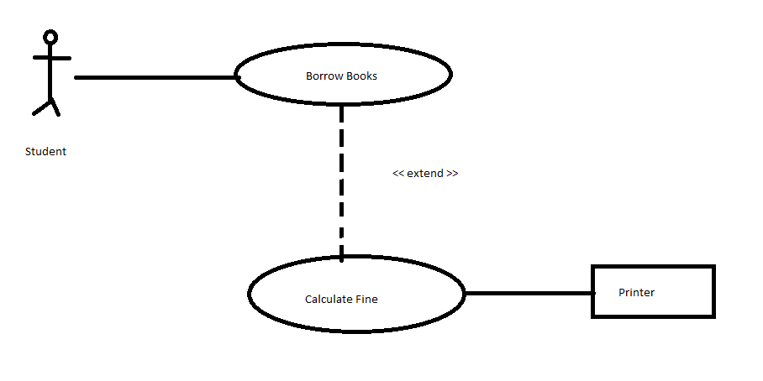

Use case for Admin:

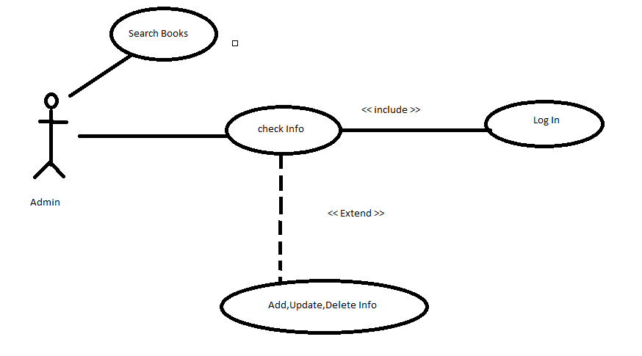

# Entity relationship diagram of the project

**Entity Set Names of the Project:**

* Student
* Books
* Admin
* Employee
* Publisher
* Author
* Supplier

**Entities & Attributes with Specified Data Types & Keys:**

1. **Entity Name:** Student

**Attributes Name:**

* Student_id : int (primary key)
* Student_name : varchar
* Student_dept: varchar
* Student_image : varchar
* Student_contact: varchar
* Student_email:varchar
* enrollment_no:int

1. **Entity Name:** Books

**Attributes Name:**

* books_id : int (primary key)
* books_name : varchar
* books_price : int
* author_name: varchar
* publisher_name:varchar
* available_quantity:int

1. **Entity Name:** Admin

**Attributes Name:**

* id : int (primary key)
* full_name : varchar
* user_name: varchar
* email:varchar
* password:varchar
* contact:varchar

1. **Entity Name:** Employee

**Attributes Name:**

* emp_id : int (primary key)
* emp_name : varchar
* emp_adress : varchar
* emp_email : varchar
* emp_contact : varchar

1. **Entity Name:** Author

**Attributes Name:**

* Author_id : int (primary key)
* Author_name : varchar
* Author_email: varchar

1. **Entity Name:** Publisher

**Attributes Name:**

* Publisher_id : int (primary key)
* Publisher_name : varchar
* Publisher_address : varchar

1. **Entity Name:** Supplier

**Attributes Name:**

* Sup_id : int (primary key)
* Sup_name: varchar
* Sup_email: varchar
* Sup_address: varchar
* Sup_contact: varchar

**Pictorial Representation:**

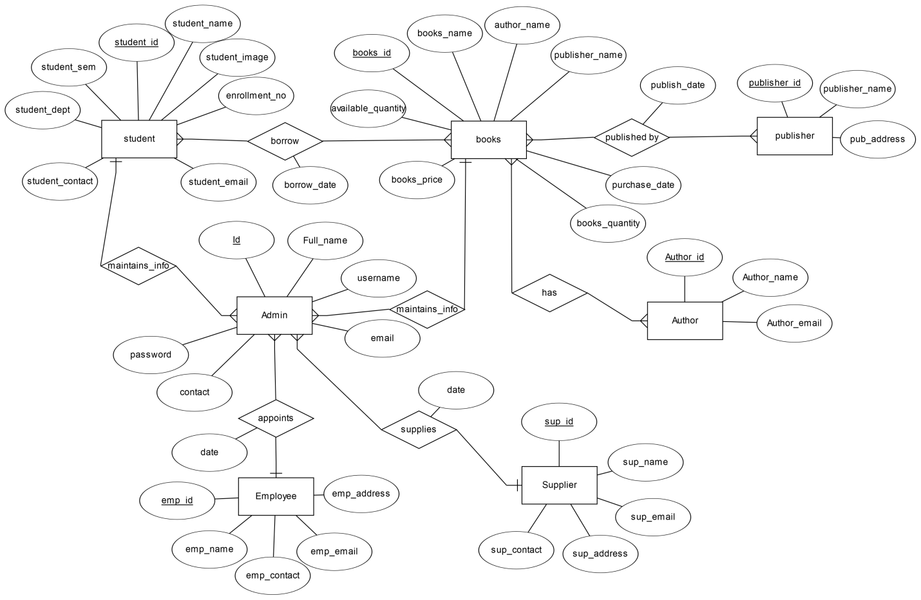 **Fig:** ERD of Library Management System

# Testing result of the project

Alpha testing

Alpha testing is conducted at the developer’s site by end users. Software is used in a natural setting with developers watching intently. Testing is conducted in a controlled environment.

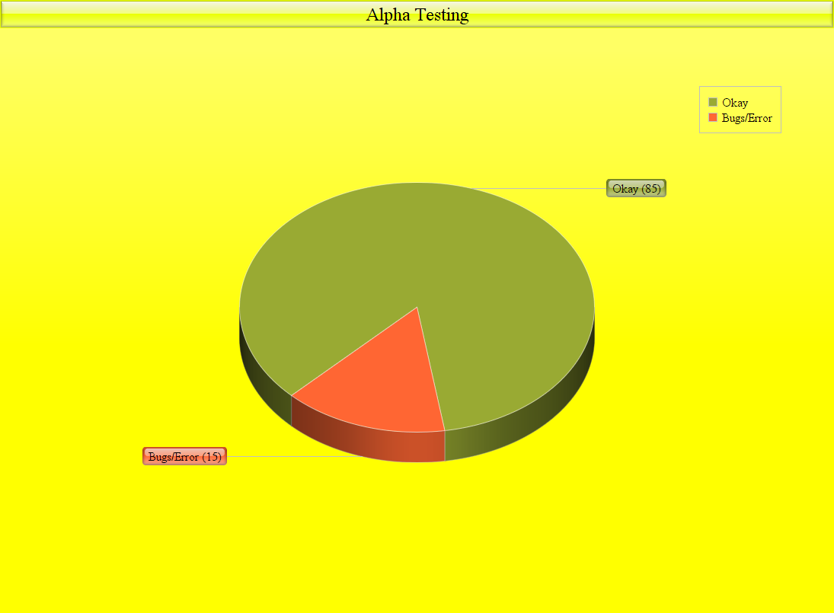

Bugs/Error we have found after Alpha testing:

1. No warning is given if user does not fill up all the fields.

2. No warning is given if user does not enter his/her contact num and email correctly

3. There was a bug in uploading picture.

4. A bug was occurred in sending emails.

We have solved all the bugs/error we have found after Alpha testing.

Beta testing

Beta testing is conducted at end-user sites. Developer is generally not present. It serves as a live application of the software in an environment that cannot be controlled by the developer. The end-user records all problems that are encountered and reports these to the developers at regular intervals.

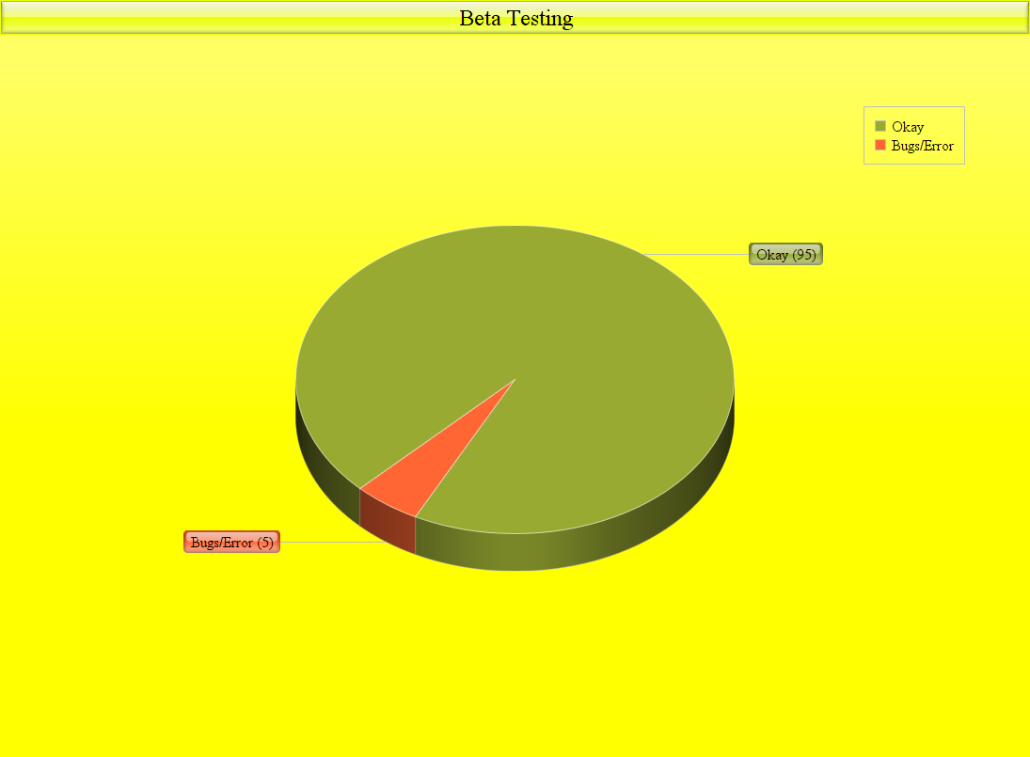

Bugs/Error we have found after Beta testing:

We give the app to some of our friends who used the application and mentioned us about some improvements and bugs to fix later on we have done some modification and fixed the bugs discovered in this phase.

We have solved all the bugs/error we have found after Beta testing.

# oppourtunities of developments

* We have tried to make our system more feasible and user friendly.
* We have tried try to create more sophisticated database.
* We have tried try to create admin login and registration option

# Benchmarking

It’s a great opportunity for us to work as a team. We have 3 members in our group:

➢ **Md. Musad Al Rubayet ID: 15.01.04.069 – > 40%**

➢ **Md. Jahid Shah Shiamun ID: 15.01.04.071 – > 30%**

➢ **Fairuz Shadmani Shishir ID: 15.01.04.082 – > 30%**

# References

1 . System Analysis And Design By Kendall and Kendall .

2 . Software Engineering: A Practitioner's Approach By Roger Pressman and Bruce Maxim.